**TABLE OF CONTENTS**

|  |  |
| --- | --- |
| **Project ECHO Overview………………………………………………………………………………………** | **1** |
| Sponsorship……………………………………………………………………………………………….. | 1 |
| What is Project ECHO? ................................................................................................................................ | 1 |
| Core Principles of Project ECHO…………………………………………………………………………. | 1 |
| **TeleECHO Overview……………………………………………………………………………………………………………………………….** | **2** |
| How Does It Work? ....................................................................................................................................... | 2 |
| How a Typical TeleECHO Clinic Session is Structured………………………………………………….. | 3 |
| CMES and CEUS………………………………………………………………………………………. | 3 |
| Curriculum………………………………………………………………………………………………… | 4 |
| Evaluation Process………………………………………………………………………………… | 4 |
| **Case Presentations…………………………………………………………………………………………….** | **4** |
| What Cases Should I Present? …………………………………………………………………………….. | 4 |
| What Information Should Be Included in a Case Presentation? …………………………………………… | 4 |
| How to Present a Case……………………………………………………………………………………. | 5 |
| **Logistics………………………………………………………………………………………………………..** | **5** |
| How Do I Join the OUD ECHO? …………………………………………………………………………. | 5 |
| How Do I Get Zoom? …………………………………………………………………………………...... | 5 |
| Connecting to a TeleECHO Clinic Session……………………………………………………………….. | 6 |
| How Can I Receive Technical Support? ........................................................................................................ | 6 |
| Contact Information……………………………………………………………………………………… | 6 |
| **Resource Information and Materials……………………………………………………………………........** | **7** |
| Zoom Instructions……………………………………………………………………………………….. | 8 |
| General Reminders……………………………………………………………………………………… | 11 |
| Getting Set Up in your Videoconferencing Location……………………………………………………. | 12 |
| Videoconferencing Etiquette……………………………………………………………………………. | 13 |
| HIPAA Identifiers………………………………………………………………………………………. | 13 |
| Q & A Fact Sheet for Providers and Health Center Leadership………………………………………... | 15 |
| Project ECHO Handouts……………………………………………………………………………… | 18 |
| Project ECHO Glossary of Terms………………………………………………………………………. | 21 |

**PROJECT ECHO OVERVIEW**

**Sponsorship**

The Opioid Use Disorder (OUD) TeleECHO™ Clinic hosted by Indiana University School of Medicine, in partnership with the Indiana Prevention Resource Center, has been made possible through a 21st Century Cures grant, which was awarded to Indiana University by the Indiana Division of Mental Health and Addiction. Participation is free and is open to healthcare providers in the state of Indiana.

**What is Project ECHO?**

Project ECHO (Extension for Community Healthcare Outcomes) is a guided-practice model that aims to increase workforce capacity by sharing knowledge. Specialists at the “hub” site meet regularly with primary care providers in local communities via videoconferencing to train primary care providers in the delivery of specialty care services.

The ECHO model™, developed at the University of New Mexico Health Sciences Center, does not provide care directly to patients. Instead, it provides front-line clinicians with the knowledge and support they need to manage patients with complex conditions in the patients’ own communities. This dramatically increases access to specialty treatment, particularly in rural and underserved areas.

Since the start of Project ECHO in 2003, the model has greatly expanded and has been implemented by over 167 partners – both in the U.S. and internationally – covering more than 100 complex conditions and problems.

Through telementoring, ECHO creates access to high-quality specialty care in local communities. Through hub and spoke knowledge-sharing, networks create a learning loop

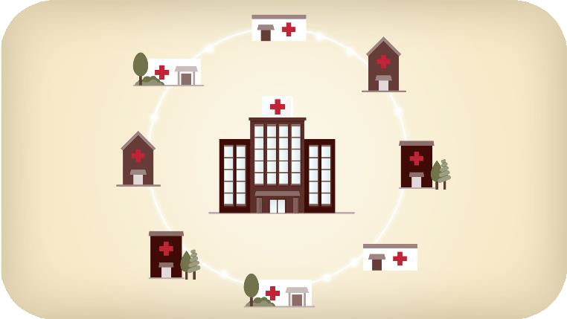

**Hub and spoke knowledge-sharing networks create a learning loop:**

* Community providers learn from specialists.
* Community providers learn from each other.
* Specialists learn from community providers as best practices emerge.

**Core Principles of Project ECHO**

The ECHO model develops knowledge and capacity among community clinicians through ongoing telementoring and education. Its core principles are:

* Use technology to leverage scarce resources
* Share “best practices” to reduce disparities
* Use case-based learning to master complexity
* Monitor outcomes using a web-based database

**TeleECHO OVERVIEW**

**How Does It Work?**

A teleECHO clinic is essentially virtual chart rounds. Participants from multiple locations connect at regularly scheduled times with a specialist or team of specialists through videoconferencing. During teleECHO clinics, providers present de-identified patient cases to specialists or expert teams who then mentor the providers as they learn to manage patients with complex conditions. These case-based discussions are supplemented with short didactic presentations to improve content knowledge and share evidence-based practices.

As a participating healthcare provider in the OUD TeleECHO Clinic, you can:

* Present and discuss your challenging cases.
* Enhance your ability to extend specialty care to your patients.
* Reduce your patients’ travel time and wait time for specialty care.

Currently, we will be conducting 3 separate ECHO tracks for the following disciplines:

1. Prescribers (MD, DO, NP) who have or who are planning to obtain their SAMHSA waiver to prescribe or dispense buprenorphine for OUD
2. Therapists (psychologists, social workers, counselors, etc.)
3. Community Health Workers/Peer Recovery Coaches/Community Advocates who provide direct care

In the future we will also be rolling out 4 additional tracks:

1. Treating pregnant women with OUDs
2. Treating adolescents with OUDs
3. Helping First Steps workers learn about identifying and referring people with OUDs
4. Supporting peer recovery coaches working in emergency departments

ECHO participation benefits Indiana healthcare providers and institutions by:

* Enabling providers to practice at the top of their licenses, confidently treating patients with common complex conditions.
* Allowing patients to stay in their local communities and receive treatment from their healthcare providers.
* Enhancing healthcare providers to acquire new skills and competencies.
* Increasing professional satisfaction as rural providers become part of a community of practice and learning. This allows providers to be more productive, and motivates them to stay in rural communities longer.

OUD TeleECHO Clinics: Empowering Healthcare Professionals and Community Health Workers Clinicians who care for patients in a rural healthcare setting face unique challenges related to OUD. Frequently, access to specialty care is minimal, patients have fewer resources than in the urban environment (particularly

those in impoverished areas with uninsured patients), and there are significant cultural and demographic

factors that can impact all aspects of clinical care.

Reducing the burden of OUD has important implications for individuals and is a critical public health need. While there are a variety of behavioral and pharmacological therapies available for OUD, treatment has been out of reach for many patients due to the lack of healthcare professionals trained to treat OUD in rural communities. The OUD ECHO program provides an innovative and evidence-based approach to increasing access to OUD care in rural communities by bringing together specialists and non-specialists using a web-based platform to improve care for patients in the communities where they live and work.

**How a Typical TeleECHO Clinic Session is Structured**

TeleECHO clinic sessions take place via real-time, interactive videoconferencing, using a PC/Mac, laptop, tablet, or smart phone equipped with a webcam, and a versatile, user-friendly, HIPAA- compliant, cloud-based software application called Zoom. Zoom is available at no cost to participants

The expert team will include specialists in the treatment of OUD and community healthcare providers from a variety of settings, including primary care practices, behavioral health specialists, peer recovery coaches, pharmacist and experts that deal with legal aspects of treating OUD. We encourage all types of providers to participate and to attend clinic sessions on a regular basis throughout the course of the program. Entire clinics can participate at one time.

* The Prescriber sessions are held every Wednesday, from 12:00 PM – 1:30 PM ET.
* The Behavioral Health sessions are held every Thursday from 1:00 PM- 2:30PM ET.
* Community Health Worker Track: *Coming Soon*!

Each session begins with participant introductions, followed by a brief didactic presentation on a topic related to the care of patients with OUD. Each clinic runs for 12 weeks.

Community healthcare providers who have previously volunteered then present de-identified cases of patients with OUD for discussion by the entire group. In order to protect patient confidentiality, PHI SHOULD NEVER BE USED DURING ECHO CLINICS. Instead, an assigned, confidential ECHO ID# is used to identify and refer to a patient. A Case Presentation Form submitted via a survey instrument called Qualtrics, is used for entering pertinent medical information. All participants are encouraged to contribute actively to the case discussions.

Recommendations are summarized verbally at the conclusion of each case presentation, and forwarded in writing to the healthcare provider whose case was discussed.

**Continuing Education Credits (CMES and CEUS)**

**Continuing Medical Education Credits**

The Indiana University School of Medicine is accredited by the Accreditation Council for Continuing Medical Education (ACCME) to provide continuing medical education for physicians.

The Indiana University School of Medicine designates this live educational activity for a maximum of 1.5 AMA PRA Category 1 Credit(s)™. Physicians should only claim credit commensurate with the extent of their participation in the activity.

In accordance with the Accreditation Council for Continuing Medical Education (ACCME) Standards for Commercial Support, educational programs sponsored by the Indiana University School of Medicine must demonstrate balance, independence, objectivity, and scientific rigor. There are no relevant financial relationships with ACCME-defined commercial interests for anyone who was in control of the content of this activity.

CME will be provided to all members at no cost. A short post-session evaluation is required in order to receive CME credits. For each session attended, providers will receive 1.5 credits. To claim this credit please text the code 40921 to 317-671-8998. Credit can be claimed 60 minutes prior and 120 minutes after each session.

Visit http://go.iu.edu/MyCME to complete one time set up prior to the first session.

**Continuing Education Units**

This activity is qualifies 1.5*Category I Continuing Education Units* for Social Workers, Clinical Social Workers, Marriage and Family Therapists, Marriage and Family Therapy Associates, Mental Health Counselors, Mental Health Counselor Associates, Addiction Counselors, and Clinical Addiction Counselors as outlined by the Indiana Behavioral Health and Human Services Licensing Board pursuant to Indiana Code 25-1-4-0.2.

CEU will be provided to all members at no cost. A short post-session evaluation is required in order to receive CEU credits. For each session attended, providers will receive 1.5 credits. To claim this credit please text the code 40921 to 317-671-8998. Credit can be claimed 60 minutes prior and 120 minutes after each session.

Visit <http://go.iu.edu/MyCME> to complete one time set up prior to the first session.

**Curriculum**

The formal didactic curriculum for the sessions in this program was developed by our OUD ECHO team to provide a thorough introduction to OUD treatment and care. Sample topics include neurology and diagnosis of OUD, use of Medicated Assisted Treatment (MAT), treating pain in the setting of prescription OUD and harm reduction strategies, to name a few. Participants will be able to view the PowerPoint slides on screen during the didactic presentation.

*\*Please note that teleECHO clinics may be recorded for educational and quality improvement purposes. By participating in a clinic session, you are consenting to be recorded.*

**Evaluation Process**

It is critically important for us to evaluate the efficacy of our curriculum and program; thus, we ask that ECHO participants complete a short pre- and post-skills assessment survey before and after completion of the series, as well as a brief survey after each clinic session.

**CASE PRESENTATIONS**

**What Cases Should I Present?**

You do not need to present a case during every session in order to participate in the OUD clinic. However, the submission of cases for presentation and discussion is a key component in the Project ECHO model and critically important for knowledge building and sharing, and it is therefore required that each provider present at minimum two cases. We welcome cases that involve common clinical scenarios related to OUD diagnosis and care as well as difficult, complex, or challenging presentations and patient management scenarios.

**What Information Should Be Included in a Case Presentation?**

We will provide you with a fillable Case Presentation Form via an online survey tool called Qualtrics. The form will solicit demographic and relevant clinical information about the patient, including substance use history, physical exam findings, social issues, and laboratory/imaging test results. The form includes a section for listing the main question(s) you have concerning the case.

It is absolutely critical to preserve patient confidentiality at all times during case presentations. NO Identifiable Information should BE MENTIONED OR SHOWN DURING CASE PRESENTATIONS. In addition, please be aware that presenting certain information, even if de- identified, may be enough to identify individuals, particularly within small social circles or rural communities. Please do not discuss case presentations outside of ECHO sessions except when clinically necessary.

You may not have all the information requested on the Case Presentation Form, but please include as much information as you can. This will help the OUD ECHO participants address your concerns and questions.

**How to Present a Case**

* Email the Program Coordinator and submit a case via the Qualtrics link.
* An ECHO ID# will be assigned to your case, and this ID#, as well as the date of your scheduled case presentation, will be confirmed with you via email.
* During the teleECHO session, the session Facilitator will call on you to present your case. The Program Coordinator will scroll through your Case Presentation Form on screen as you present your case. All videoconferencing participants will be able to see the de-identified portion of the form. Please verbally summarize your case in five minutes’ time or less.
* The Facilitator will then promote discussion among all participants, starting with clarifying questions for the case presenter. At the conclusion of the discussion, the Facilitator will summarize recommendations from all participants.
* UNM’s Project ECHO has created the following short videos on The Correct and Incorrect Ways to Conduct an ECHO Patient Presentation. Please take a few minutes to view these

*The Correct Way to Conduct an ECHO Patient Presentation:*

https://www.youtube.com/watch?v=IUKGkoevTso&feature=youtu.be

*The Incorrect Way to Conduct an ECHO Patient Presentation:*

https://www.youtube.com/watch?v=Cghbvf-JeDw&feature=youtu.be

**LOGISTICS**

**How Do I Join the OUD ECHO?**

You can register online! Please click here and complete all fields. Each participant will need to sign up individually, even if there are several people participating from your site location. The TeleECHO Program Coordinator will contact you via email soon afterward with more information. You will be added to the email notification list and will receive regular announcements about upcoming clinic sessions.

**How Do I Get Zoom?**

You may download the free version of the Zoom client for PC or Mac by visiting https://zoom.us/download and selecting Zoom Client for Meetings. If your computer doesn’t have a built-in video camera and microphone, a simple USB webcam, such as a Logitech HD Pro Webcam C920, will fulfill this purpose if one is available. A camera is not required for participation, however it is strongly encouraged to build an engaging community of practice. You may also use a headset, if needed or preferred, instead of your device’s speakers and/or microphone. A headset may improve your overall audio experience, particularly if there are background noises in your local environment. You can also join a Zoom meeting if you use hardware-based videoconferencing equipment.

Instructions for downloading and the basic operation of Zoom are also included in this Welcome Guide. To avoid delays and other technical issues on the day of the clinic session, we advise that you schedule a time to perform a connectivity test with our ECHO IT Site Administrator and Program Coordinator in advance of the session you plan to attend (see contact information below). Once you have connected successfully and have become familiar with the operation of Zoom, you will no longer need to do a pre-session test (unless you wish to do so).

**Connecting to a TeleECHO Clinic Session**

Once you have registered, you will regularly receive email notifications from the TeleECHO Program Coordinator prior to the upcoming clinic, announcing the date, time, and title of the topic for that session’s didactic presentation. The email will include an online link to the OUD ECHO Case Presentation Form.

If you would like to present a patient case, please submit a completed Case Presentation Form to the TeleECHO Clinic Coordinator via Qualtrics. Presentation of your case will then be scheduled on a first- come, first-served basis. We will strive to schedule on the preferred date that you have indicated on the Case Presentation Form.

One or two days prior to the scheduled clinic session, we will send another email notification with the session agendas, including the listing of case presentations, information about the didactic presentation, and information on how to connect to the session.

On the day of the clinic, please join the session a few minutes prior to the scheduled start time using Zoom. This will give you sufficient time to confirm you have a stable Internet connection, test your audio and video, and get comfortably situated at your site location. The OUD ECHO team will open the Zoom meeting room connection approximately 30 minutes prior to the start time.

**How Can I Receive Technical Support?**

For questions about Zoom or preparing for a teleECHO clinic session, or to schedule a time for testing, please contact the OUD ECHO Program Coordinator who will connect you with our IT support.

**CONTACT INFORMATION**

**Kristen Kelley**, ECHO Program Coordinator

kelleykr@iu.edu; 317-431-8877

**Kaitlyn Reho**, MPH, MATS, ECHO Program Coordinator

kreho@indiana.edu; 812-856-9771

**Leila Darden**, Continuing Medical Education

ldarden@iu.edu; 317-274-3628

**Leslie Hulvershorn**, MD, Facilitator

**Zachary Adams**, Ph.D., HSPP, Facilitator

**Jon Agley**, Ph.D. Evaluator

jagley@indiana.edu; 812-855-1237

*\*With regard to the general format and partial content of this guide, we wish to acknowledge the University of Rochester Project ECHO, its CEI STD TeleECHO Welcome Packet, as well as the Arizona Telemedicine Program and its Rheumatology TeleECHO Clinic Participant Welcome Guide and the IUPUI Fairbanks School of Public Health HCV ECHO Clinic Welcome Guide.*



**Resource Information and Materials**

* Zoom Instructions and Videoconferencing Etiquette
* HIPAA Identifiers Sheet (Project ECHO)
* ECHO FAQs
* ECHO One-Pager
* ECHO Infographic
* ECHO Terms Glossary

**JOINING A MEETING WITH ZOOM**

**Downloading Zoom**

You can download Zoom by going to https://zoom.us/download and download the Zoom Client for Meetings. Once Zoom is downloaded, please click on Join a Meeting

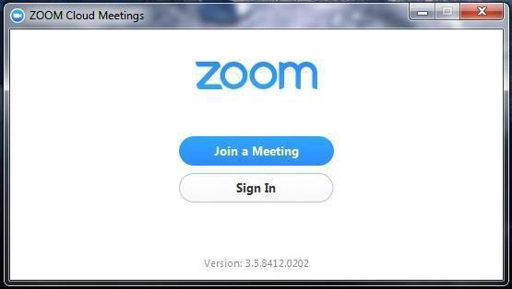

**Joining a meeting**

Please enter the clinic’s meeting ID (provided by your clinic coordinator) and click Join.

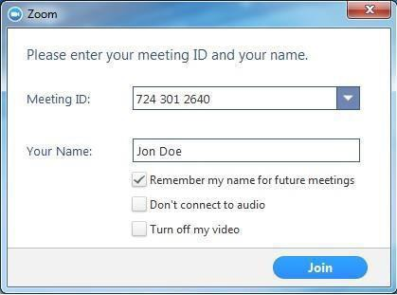

**Password**

If the Meeting or Clinic is password protected, Zoom will ask you for a password. If you’re asked for a password, enter the password and click Join.

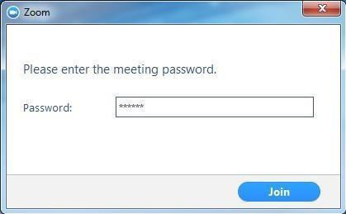

**Connecting Audio**

Once you join the meeting, a window will appear asking you to Join Audio by Computer.

Check the box for Automatically Join audio by Computer when joining a meeting in the bottom left corner of the Audio window.

*\*Selecting “Automatically Join audio by Computer when joining a meeting” allows your audio connection to be automatically established the next time you join a Zoom meeting from your computer.*

Click the **Join Audio by Computer** button.

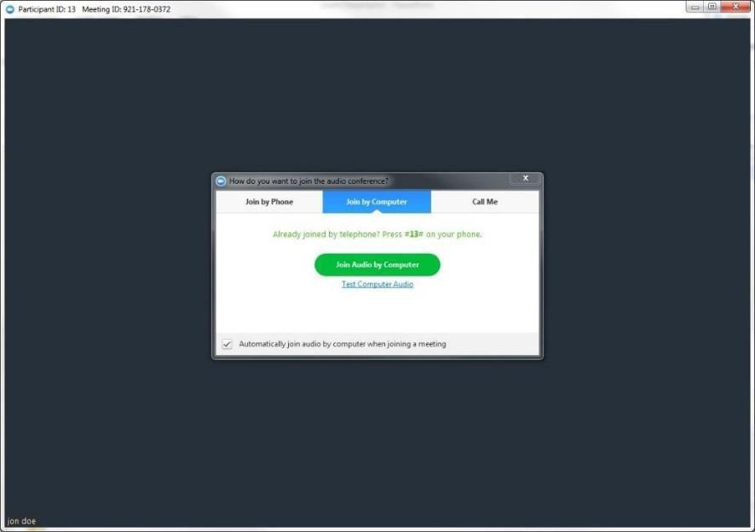

After clicking on “Join Audio by Computer”, you will see a message confirming that you’re using the audio connection on your computer.

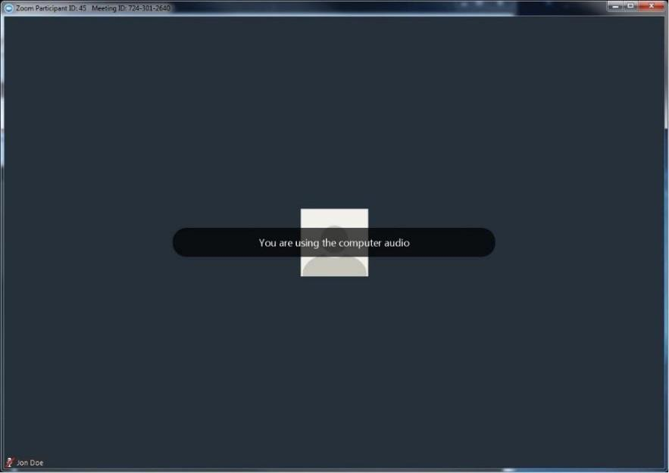

**Testing Audio**

Before the clinic begins, please test your microphone and speakers by clicking on the arrow pointing upward to the right of the microphone and selecting Audio Options.

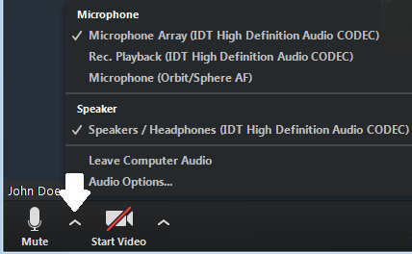

Click on **Test Computer Audio** on the next screen

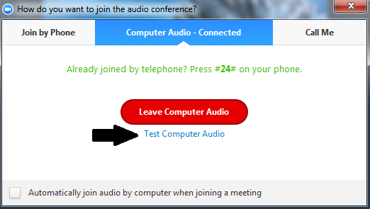

The **Test Speaker** button plays a sound to let you know the speaker is working. If you don’t hear anything, make sure your speakers are turned on. You can also select different speakers by clicking on the field next to the Test Speaker button.

The **Test Mic** button starts recording once you click it. It records a few seconds of audio and will play back the recording to let you know the mic is working. If you don’t hear anything, try selecting a different mic by clicking on the field next to the Test Mic button

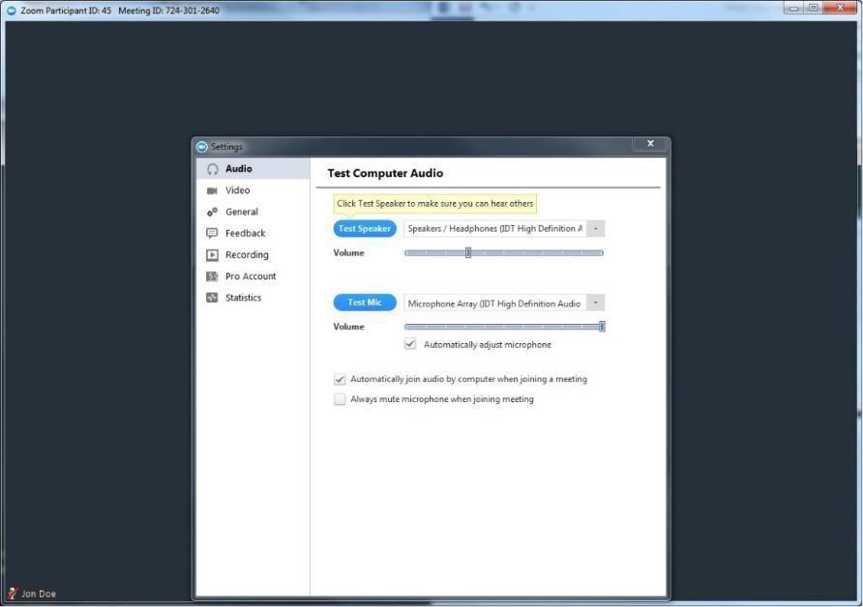

**GENERAL REMINDERS**

* Remember to mute your microphone when you’re not speaking. You can mute yourself by clicking on the microphone icon in the bottom left corner of the screen.
* Adjust your camera accordingly
  + Make sure your face is visible
  + Use front lighting instead of backlighting to prevent appearing as a shadow
* Zoom has two viewing options that can be toggled in the top right corner
  + Speaker view allows you to view only the person that’s speaking
  + Gallery view allows you to see all participants in the meeting

**GALLERY VIEW:**

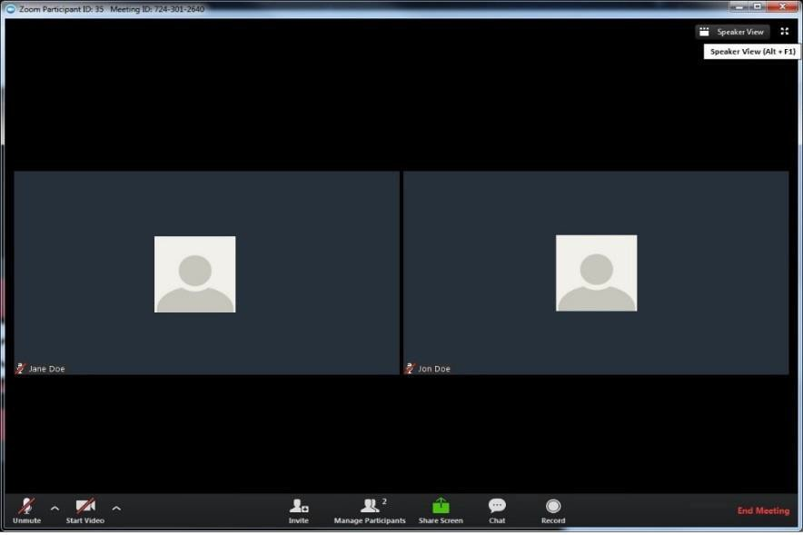

**SPEAKER VIEW:**

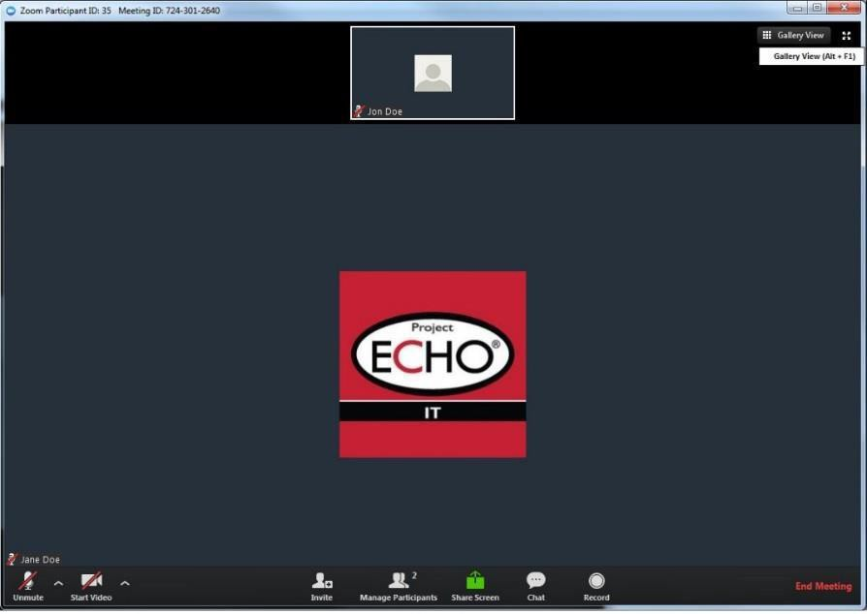

**GETTING SET UP IN YOUR VIDEOCONFERENCING LOCATION**

* Join the video call from a quiet location with minimal background/ambient noise and little or no chance of interruption during the clinic session.
* Position yourself and your video camera so that you are well lit. Avoid backlighting situations such as having a bright light source or window behind you.
* Keep in mind that others on the video call will be able to see everything that is in your camera’s field of view. Ideally, position your camera to minimize any potential visual distractions. A solid background is optimal, though this is not always possible to achieve.
* Positioning your PC/Mac/smartphone/tablet in a stationary location such as on a table or desk (using props if needed) will give others the best viewing experience of you and your location, unless you specifically need to move the camera around to show something to the group. This will also generally provide better audio performance. While videoconferencing, even subtle movement generated by hand holding a smaller device - such as a smart phone or tablet - is distracting to others.
* Position your device’s camera as close to eye level as possible.
* If you are videoconferencing as a solo participant, position yourself relative to your device’s camera so that the camera is capturing a relatively close-up view of you. Center yourself within the camera frame so that the area from the top of your head to around mid-chest level can be seen.
* If you are videoconferencing with a group of people (e.g., sitting around a table), position as many participants within the camera frame as you comfortably can. Having people sit closer together or in a configuration that maximizes inclusion within the frame while still allowing all participants to view the screen clearly and comfortably is the goal.
* If feasible, look toward the camera when speaking. This gives others on the call the best view of you while you are communicating with them and gives the appearance that you are making eye contact.
* Please fill in your name when joining the call via Zoom. You can do this by viewing the participant list at the bottom of the screen and editing your name. Your entry in the list will have “me” next to it and options for Mute/Unmute and Rename will appear. You can also just right-click on your name in the box where your self-image is and edit from there. This is the name that all others on the call will see. You can also add your healthcare center or location if you wish (Ex: Jane Doe – Yuma Regional).
* Test your audio and video prior to the start of the clinic session.

**VIDEOCONFERENCING ETIQUETTE**

* When you’re not speaking, keep your microphone muted (turned OFF). This helps cut down on extraneous background noise (e.g., paper shuffling or coughing) and also eliminates the sharing of information you’d prefer that others not hear.
* To mute your mic, click/tap on the microphone icon that appears in the lower left of the screen.
  + For PC/Mac, move the mouse pointer within the Zoom video window and look for the controls that appear along the bottom of the window.
  + For tablet or smartphone, touch the screen to display the Zoom controls and then touch the microphone icon to mute.
  + Repeat these actions to unmute the microphone when you are speaking. Return to mute when you are done.
* Communicate clearly during the clinic session. Identify yourself prior to making your comments so that everyone can recognize you (Ex: “This is Joel Avery … can you please repeat the most recent CRP result on the patient?”).
* Wait for whoever is speaking to stop talking before beginning to speak. Cross-over audio communication may result in missed points in the conversation that will need to be repeated.
* If you need to temporarily turn off your video at any point during the clinic session, click/tap on the Stop Video icon in the lower left of your screen next to the microphone mute/unmute icon. You will remain connected to the session and your audio will not be affected. To re-enable video, simply click/tap on the Start Video icon.
* Throughout the course of the clinic session, remember to never disclose protected health information (PHI). If you are presenting a case, avoid all HIPAA identifiers. Use your ECHO ID# when referring to the patient.
* If you’re on camera, others can see you clearly, just as if you were all sitting in the same room together. Be aware of your body language. Express your attentiveness and professionalism at all times.
* We are all participating in an open and welcoming learning environment. Thank you for generously sharing your knowledge and experience, so that all of us can benefit from it!

**HIPAA IDENTIFERS**

Regarding the safeguarded of patient health information (whether written, orally stated, or in electronic format) ECHO complies with State and Federal guidelines.

When presenting your patient, please use the ECHO ID number and refrain from providing information containing names, initials, living location, place of work, birth date, or any specific information about the patient that helps identify them as this is considered "protected health information." It is our responsibility to ensure the privacy of the protected health information is not disclosed.

**HIPAA PHI: List of 18 Identifiers and Definition of PHI**

|  |  |  |
| --- | --- | --- |
| 1. **NAMES** 2. All geographical subdivisions smaller than a State, including street address, city, county, precinct, zip code, and their equivalent geocodes, except for the initial three digits of a zip code, if according to the current publicly available data from the Bureau of the Census: 3. The geographic unit formed by combining all zip codes with the same three initial digits contains more than 20,000 people; and 4. The initial three digits of a zip code for all such geographic units containing 20,000 or fewer people is changed to 000. 5. All elements of dates (except year) for dates directly related to an individual, including birth date, admission date, discharge date, date of death; and all ages over 89 and all elements of dates (including year) indicative of such age, except that such ages and elements may be aggregated into a single category of age 90 or older 6. Phone numbers 7. Fax numbers |  | 1. E-mail addresses 2. Social Security numbers 3. **MEDICAL RECORD NUMBERS** 4. Health plan beneficiary numbers 5. Account numbers 6. Certificate/license numbers 7. Vehicle identifiers and serial numbers, including license plate numbers 8. Device identifiers and serial numbers 9. Web Universal Resource Locators (URL) 10. Internet Protocol(I) address numbers 11. Biometric identifiers, including finger and voice prints 12. Full face photographic images and any comparable images 13. Any other unique identifying number, characteristic, or code (note this does not mean the unique code assigned by the investigator to code the data). |

There are also additional standards and criteria to protect individual’s privacy from re-identification. Any code used to replace the identifiers in datasets cannot be derived from an information related to the individual and the master codes, nor can the method to derive codes be disclosed. For example, a subject’s initials cannot be used to code their data because the initials are derived from their name.

Additionally, the researcher must not have actual knowledge that the research subject could be re-identified from the remaining identifiers in the PHI used in the research study. In other words, the information would still be considered identifiable if there was a way to identify the individual even though all of the 18 identifiers were removed.

**Join the OUD ECHO**

* Learn how to treat OUD
* Get no cost CME or CEU credit



**Q & A Fact Sheet for Providers & Health Center Leadership**

1. **What is ECHO?**

During a teleECHO clinic, using multi-point video technology, primary care providers in multiple locations present patient cases to a multidisciplinary team of specialists to determine treatment. These specialists serve as mentors, training community providers to provide care in clinical areas that were previously outside their expertise. Over time the primary care providers operate with increased independence as their skills and self-efficacy grow.

1. **How is the ECHO model™ different from traditional telemedicine?**

The ECHO model is not ‘traditional telemedicine’ where the specialist assumes care of the patient, but instead a guided practice model where the primary care provider retains responsibility for managing the patient.

1. **What is a teleECHO clinic?**

A teleECHO clinic is, essentially, virtual grand rounds. Primary care providers from multiple locations connect at regularly scheduled times with a team of specialists using low-cost, multi-point videoconferencing. During teleECHO clinics providers present patient cases to specialist expert teams who mentor the providers to manage patients with common, complex conditions. These case based discussions are supplemented with short didactic presentations to improve content knowledge and share evidence based best practices. Providers can connect to a teleECHO clinic that is focused on a complex condition that is of interest to them. There are currently over 45 different teleECHO clinics focused on conditions such as chronic pain, HIV, hepatitis C, addictions, and diabetes, just to name a few. Providers also received free CME credits for each teleECHO clinic attended.

1. **Why should I or my health center consider participating in a teleECHO clinic?**

Project ECHO is a unique tool that enables providers to improve their expertise while treating patients with common complex conditions rather than referring them on. Increased patient retention and satisfaction keeps patients at their local health center, and treated within their local community.

* **Physician/PA/NP Development and Retention:** Through Project ECHO, primary care providers acquire new skills and competencies, expanding access to care. They become part of a community of learners, increasing professional satisfaction and decreasing feelings of professional isolation. For a health center, this means that providers are more productive and stay in their positions longer.
* **Continued Learning:** Health centers and their providers also enjoy no-cost access to continued learning and specialist consultations during the teleECHO clinics. This enables health centers to be part of a knowledge network.
* **Increased efficiency:** ECHO has allowed health centers to see more patients and to better utilize their staff to serve more patients overall. The model allows health centers to be part of a professional network and referral network, making it easier to get patients into be seen, a process which previously could take weeks. This standardization of ‘best practices’ also strengthens the health system as a whole.

1. **What are the benefits of Project ECHO for patients?**

The ECHO model dramatically improves health outcomes for patients while bolstering patient retention and satisfaction. When a local health center adopts ECHO, many patients no longer have to travel long distances to see a specialist, a journey which is often very difficult for those with chronic conditions, and prohibitively expensive. With ECHO, patients with a wide range of chronic, complex conditions can be treated close to home, without waiting months for an appointment. The ECHO model has also demonstrated that when patients are treated in their local communities, by Providers they know and trust, it enhances their adherence to treatment and follow-up care. Expert consultations between providers and academic specialists also directly impact the health of patients, who benefit from the provider’s increased knowledge of best practices.

1. **What issues or challenges have health centers had in participating in teleECHO clinics?**

Time constraints have been identified as one of the most significant challenges for health centers. The specialist teams, or ‘hubs’, often work to schedule the teleECHO clinics either before office hours or during lunch so as not to take away from provider-patient time. Participating in Project ECHO via video conferencing requires broadband internet access at every site, which has not been an issue for the health centers currently participating in the model.

1. **How much time can I expect participation in a teleECHO clinic to take?**

Most OUD teleECHO clinics will last 90 minutes and are scheduled for every week. Our teleECHO clinics are scheduled during lunch to provide little disruption to clinic hours.

1. **Can participation in Project ECHO help me recruit and retain providers?**

Project ECHO is a powerful tool in recruiting and retaining providers. Both in rural and urban areas, health center providers often feel professionally isolated. ECHO is a major selling point for providers, as it allows for professional development, CME credits, and access to a knowledge network of peers and experts. Providers participate in the ECHO model first and foremost to help their patients, and the model increases their capacity to do so. Increased provider satisfaction often results in greater provider retention.

1. **Who should participate in teleECHO clinics? Providers as individuals? Teams? Community Health Workers (CHWs)?**

All levels of providers are welcome and highly encouraged to participate in teleECHO clinics including: physicians, physician assistances, nurse practitioners, registered nurses, psychiatrists, social workers, CHWs, and pharmacists.

1. **How much does it cost to participate in a teleECHO clinic?**

Participation in teleECHO clinics is free. The only associated costs are those for IT equipment (if needed) and time away from clinic. Many teleECHO clinics are offered early in the morning or during lunch hours to minimize the time away from direct patient care. Most clinics already possess the required IT equipment to connect via video (Internet and webcam) so no additional costs are incurred. Additionally teleECHO clinics can be accessed via a smart phone application.

1. **How much does it cost to participate in a teleECHO clinic?**

Participation in teleECHO clinics is free. The only associated costs are those for IT equipment (if needed) and time away from clinic. Many teleECHO clinics are offered early in the morning or during lunch hours to minimize the time away from direct patient care. Most clinics already possess the required IT equipment to connect via video (Internet and webcam) so no additional costs are incurred. Additionally teleECHO clinics can be accessed via a smart phone application.

1. **What IT equipment is required to participate in a teleECHO clinic?**

The technology can be as simple as an individual using a laptop, a hand-held mobile device, a small room set-up for 1-2 people or a videoconferencing room to allow the participation of groups. ECHO clinics utilize a cloud-based, system called Zoom (http://zoom.us). This system has a number of benefits, including the ability to run on lower-speed Internet connections. Zoom works well on mobile devices such as iPhones, iPads and Androids, requires no appliances and has web- conferencing features like chat and sharing.

1. **How can I connect with the OUD ECHO hub? What other teleECHO clinics are available in Indiana?**

If you are interested in joining the OUD ECHO, please contact ECHO Program Coordinator, Kristen Kelley kelleykr@iu.edu.

There is also a HCV ECHO through the IUPUI Fairbanks School of Public Health. More information about that can be found by clicking [here](https://fsph.iupui.edu/research-centers/centers/public-health-practice/echo.html).

1. **How do I get no-cost CMEs and/or CEUs by participating in teleECHO clinics?**

Participants who join teleECHO clinics receive CMEs for the total time spent participating, including didactics and patient-case presentations. CME credit is offered by the Indiana School of Medicine Division of Continuing Medical Education. All CMEs from participation in teleECHO clinics are given at no charge. A text code will be displayed on the screen the day of the virtual clinic. You will have 60 minutes prior, during, and 120 minutes after the end of the session to text your attendance.

Participants who join teleECHO clinics receive CEUs for the total time spent participating, including didactics and patient-case presentations. CEU credit is offered by the Indiana School of Medicine Division of Continuing Education. All CEUs from participation in teleECHO clinics are given at no charge. A text code will be displayed on the screen the day of the virtual clinic. You will have 60 minutes prior, during, and 120 minutes after the end of the session to text your attendance.

1. **Where can I go to learn more about the Project ECHO model?**

To learn more about the ECHO model visit http://echo.unm.edu/.



*[Insert Infographics Here in PDF format]*



|  |  |
| --- | --- |
| **GLOSSARY OF TERMS** | |
| **TERM** | **DEFINITION** |
| Demonopolize | Share freely with others particularly in the case of knowledge to enable others to become equally expert. |
| Dry Run | A rehearsal that is scheduled prior to the teleECHO clinic launch where hub sites check VTC capability of the hub and spoke sites and to provide housekeeping information. |
| ECHO® | Extension for Community Healthcare Outcomes |
| ECHO Institute™ | Refers to Project ECHO’s legal entity, faculty and staff as well as headquarters and physical location at UNMHSC in Albuquerque, NM. |
| ECHO Model™ | Developed as a platform for both healthcare service delivery and research in 2003. The ECHO model is based on four core pillars: 1. use technology to leverage scarce resources, 2. sharing “best practices” to reduce disparities, 3. case-based learning to master complexity, and 4. a web-based database to monitor outcomes. The ECHO model develops knowledge and capacity among community clinicians through on-going telementoring and education. |
| Force Multiplication | Refers to an exponential increase in workforce capacity created through the ECHO model. Utilizing telementoring and guided practice ECHO builds system capacity by empowering primary care providers to gain new knowledge and expertise to treat patients in their own communities. |
| Hub | Regional center where multidisciplinary team of subject matter experts for a teleECHO clinic is located. |
| iECHO | Project ECHO’s web-based partner relations management tool that is used to manage teleECHO clinics, collect data on teleECHO clinic participation, and provide online resources to partners. |
| Immersion | Three day in-depth training for those that are ready to implement the ECHO model and have signed Project ECHO’s partnership documents. Allows partners to delve deeper into skills and resources needed while developing ongoing relationships with ECHO staff to allow for successful replication. |
| IT Support Techs | Project ECHO IT employee dedicated to managing and coordinating participant technological connections to the teleECHO clinics. |
| Knowledge Networks | Consists of regularly scheduled teleECHO clinics that bring together expert inter- disciplinary specialists and community-based partners. |
| Learning Loops | The sharing of knowledge between experts and community partners through active participation in teleECHO clinics. |
| MetaECHO™/ MetaECHO™ Community | Refers to the ever expanding community of individuals and organizations using the ECHO model to help demonopolize expert knowledge. |
| Mock TeleECHO™ Clinic (Mock ECHO) | Simulated teleECHO clinics that are designed to prepare hub team members for launching live teleECHO clinics. |
| Orientation | Full-day of presentations on the ECHO model in Albuquerque, NM including the mission/model, IT and ECHO applications, implementation next steps, evaluation, and snapshots of ECHO programs. |
| Partner Liaison | This expert on the ECHO model provides direction to partners with next steps and individualized attention that is crucial to considering details involved in launching a new and successful ECHO program. |
| Project ECHO® | Refers to the overall movement to implement the ECHO model, including the ECHO Institute. |
| Replication | Implementation and adaption of the ECHO model based on community needs and resources with training and technical assistance from the ECHO Institute and other superhubs. |
| Session | Refers to an individual teleECHO clinic occurrence. |
| Spoke | Community partner site at which individual or team of learners is located and connects to hub via teleECHO clinics. |
| TeleECHO™ Clinic | Term used to describe regularly scheduled videoconferencing sessions which include subject matter experts and learners who use the ECHO model, didactic presentations and case-based learning to create learning loops. TeleECHO clinics are a core feature of the ECHO model. |
| ECHO Medical Lead | The ECHO Medical Lead assists in curriculum development for the educational and training component of the teleECHO clinic and assists in coordinating teleECHO clinic functions. |
| ECHO Director | The ECHO Director assists in curriculum development for the educational and training component of the teleECHO clinic, assists in coordinating teleECHO clinic functions and provide strategic direction to the ECHO team. |
| ECHO Program Coordinator | The ECHO Program Coordinator who is responsible for the administrative and organizational component of a teleECHO clinic, assists in coordinating teleECHO clinic curriculum development, and provides guidance information to teleECHO clinic participants and teleECHO clinic guest speakers. |
| Telementoring | Term used to describe the guided mentoring relationship that develops during a teleECHO clinic using videoconferencing technology. |
| UNMHSC | University of New Mexico Health Sciences Center, where the ECHO Institute is based in Albuquerque, NM. |
| VTC | Video teleconferencing; participation in teleECHO clinics via video connection (like Zoom). |
| Zoom | Teleconferencing software used for teleECHO clinics. |